# Lecture # 10:

**Objective:**

* List Box Example
* Data Grid View

# List Box:

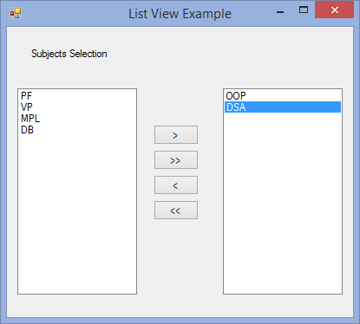

using System;

using System.Collections.Generic; using System.ComponentModel; using System.Data;

using System.Drawing; using System.Linq; using System.Text;

using System.Windows.Forms;

namespace COMBOBOX

{

public partial class listViewExample : Form

{

public listViewExample()

{

InitializeComponent();

}

private void btnSelect_Click(object sender, EventArgs e)

{

int index = lstbxSubjects.SelectedIndex; if (index == -1)

{

}

else

{

string item = lstbxSubjects.SelectedItem.ToString(); lstbxSubjects.Items.RemoveAt(index); lstbxSelected.Items.Add(item);

}

}

private void btnSelectAll_Click(object sender, EventArgs e)

{

foreach (string item in lstbxSubjects.Items)

{

lstbxSelected.Items.Add(item);

}

lstbxSubjects.Items.Clear();

}

private void btnUSel_Click(object sender, EventArgs e)

{

int index = lstbxSelected.SelectedIndex; if (index != -1)

{

string item = lstbxSelected.SelectedItem.ToString(); lstbxSelected.Items.RemoveAt(index); lstbxSubjects.Items.Add(item);

}

}

private void btnUSelAll_Click(object sender, EventArgs e)

{

foreach (string item in lstbxSelected.Items)

{

lstbxSubjects.Items.Add(item);

}

lstbxSelected.Items.Clear();

}

}

}

# Data Grid View:

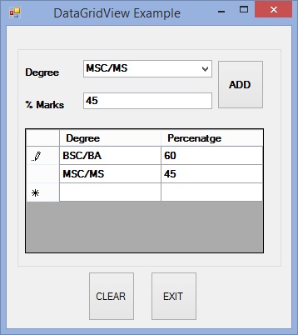

using System;

using System.Collections.Generic; using System.ComponentModel; using System.Data;

using System.Drawing; using System.Linq; using System.Text;

using System.Windows.Forms;

namespace COMBOBOX

{

public partial class DataGridViewExample : Form

{

public DataGridViewExample()

{

InitializeComponent();

}

private void btnAdd_Click(object sender, EventArgs e)

{

if (cmbxDegree.SelectedIndex == -1)

{

MessageBox.Show("Select Degree"); cmbxDegree.Focus();

}

else if (txtMarks.Text == string.Empty)

{

MessageBox.Show("Enter Percentage");

txtMarks.Focus();

}

else

{

txtMarks.Text);

try

{

}

float ehPer = float.Parse(txtMarks.Text); dgvRecords.Rows.Add(cmbxDegree.SelectedItem.ToString(),

catch (Exception)

{

MessageBox.Show("Percentage should be numeric"); txtMarks.Focus();

}

}

}

private void btnClear_Click(object sender, EventArgs e)

{

cmbxDegree.Text = string.Empty; txtMarks.Text = string.Empty; dgvRecords.Rows.Clear();

}

private void btnExit_Click(object sender, EventArgs e)

{

Application.Exit();

}

}

}